Student Resource 13.1
Reading: An Introduction to Life Insurance
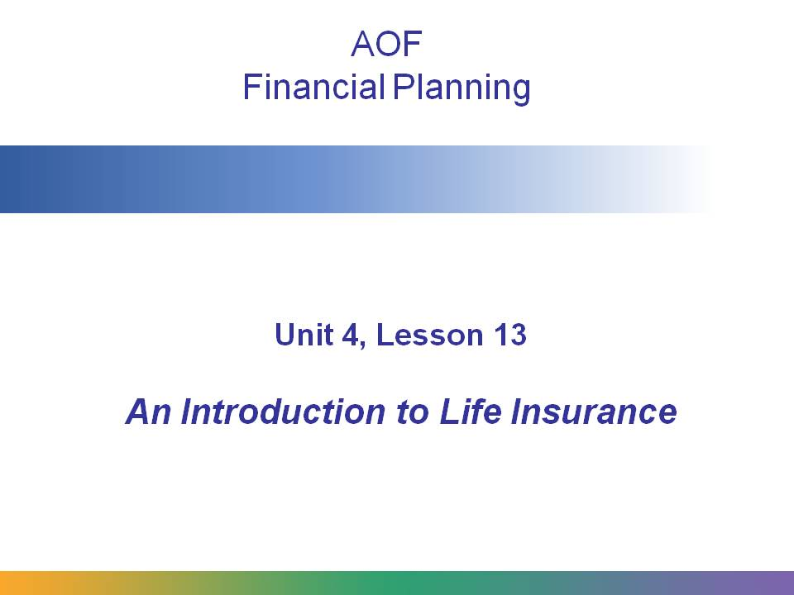
This presentation on life insurance will cover the following topics:
- Why life insurance is an important part of a financial plan
- How life insurance works
- How insurance companies decide how much to charge
- Types of life insurance
- Other types of similar insurance
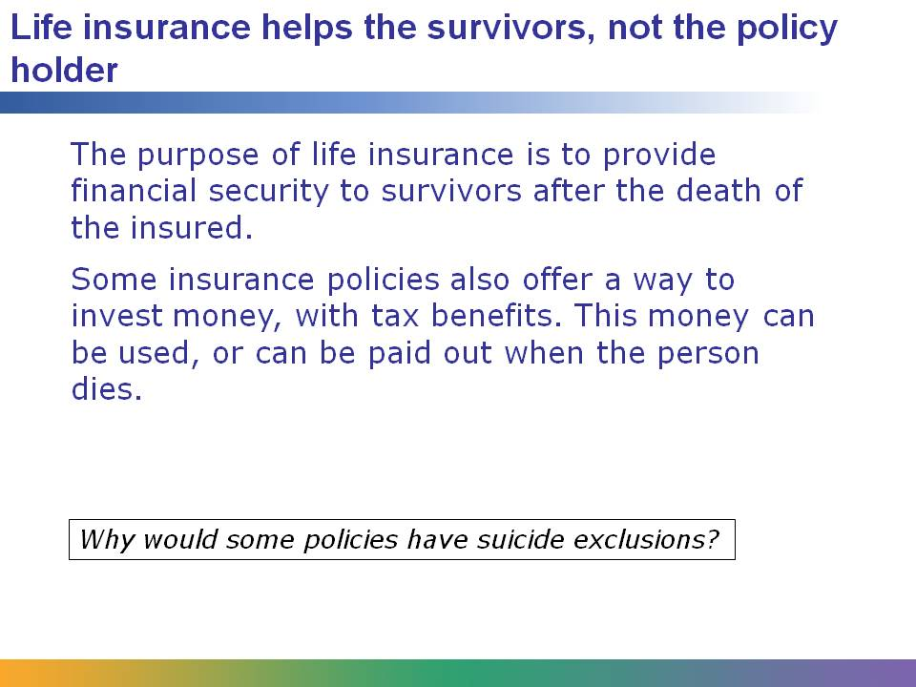
The purpose of life insurance is to provide financial security to beneficiaries after the insured person dies. (Also, in some cases, insurance policies can be a way to invest money.)
Most insurance policies have suicide exclusions for two years after the policy is purchased.
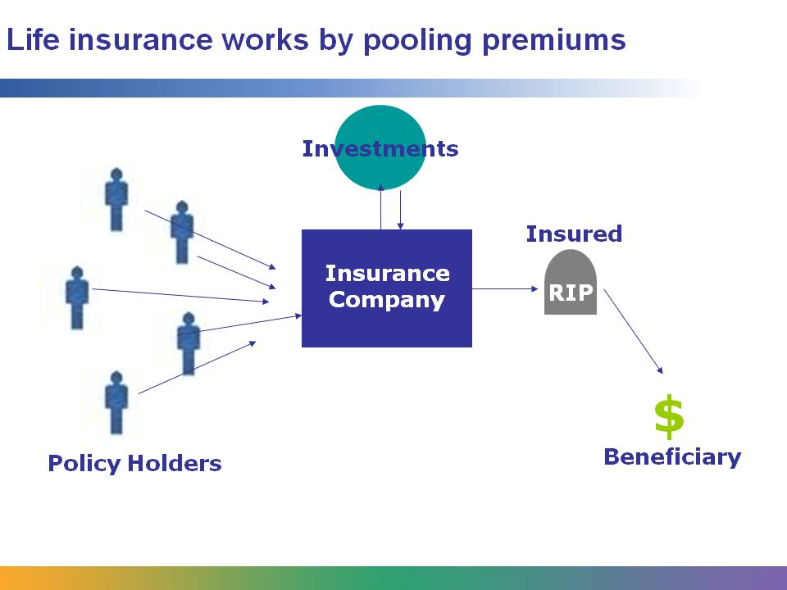
Insurance companies receive premiums and invest them to create a pool of money. Proceeds may be paid as a lump sum or as an annuity (paid over time in regularly recurring payments). Insurance companies pay out to the beneficiary or beneficiaries when the insured person dies.
The policy holder is the person that purchases and pays for the insurance policy. The insured is the person who is covered. When the insured dies, it is the beneficiary or beneficiaries who are paid by the insurance company. The policy holder does not have to be the insured person! The policy holder can be the beneficiary.
There is a rule that says the policy holder must have an insurable interest in the insured. Why do you think this is so?

The three main variables in approving and setting premiums are age, gender, and tobacco use. (Sometimes lifestyle is also considered.)
In order to find out how much to charge so they can still make a profit, insurance companies use mortality tables created by actuaries. Mortality tables contain all the statistics to show how likely it is for a person to die at a certain age.
Insurance companies investigate those applying for insurance and don’t have to insure some people for health or lifestyle reasons. However, the companies must comply with the Civil Rights Act and cannot discriminate. Policies can be declined or rated (premiums are raised).
What are some lifestyle activities or types of jobs that might cause an insurance company to increase a premium or decline a policy?
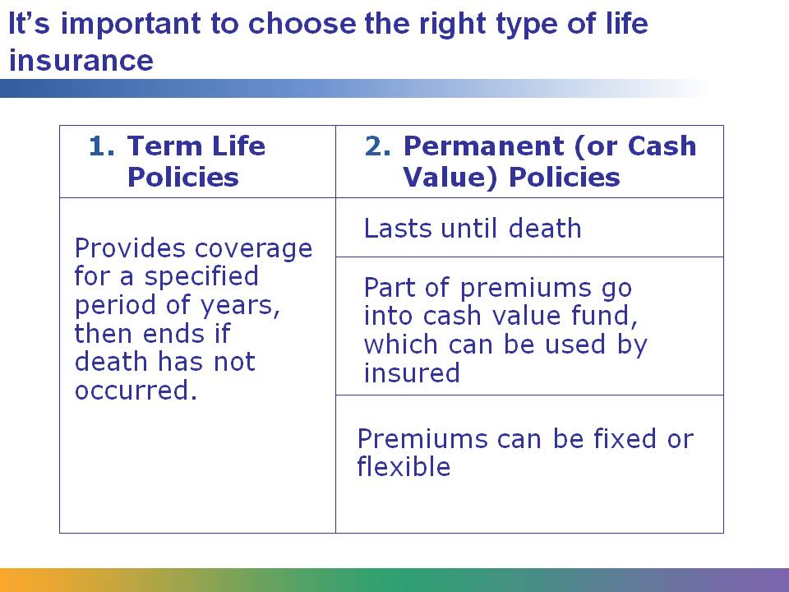
There are two main categories of life insurance: protection policies and investment policies. Term life insurance is the primary type of protection insurance. It provides coverage for a specified term of years, for a specified premium. Term insurance premiums are typically low because both insurer and insured agree death is unlikely during the terms of coverage.
When taking out a term policy, three things need to be decided: face amount (how much will be paid on the death of the person insured), the cost of the premium, and length of coverage (term).
Permanent or cash value insurance policies remain in force until the policy matures (usually at age 95 to 100) and then pay out. The policy cannot be cancelled by the insurer. The policy owner can access money in the cash value fund by withdrawing, borrowing, or surrendering (cashing in) the policy and getting the surrender value. For a whole life policy, the premium is set⎯with a set amount of money going into the cash value fund. With a universal life policy, premiums are flexible, so more money can go into the cash value fund, usually with tax advantages.

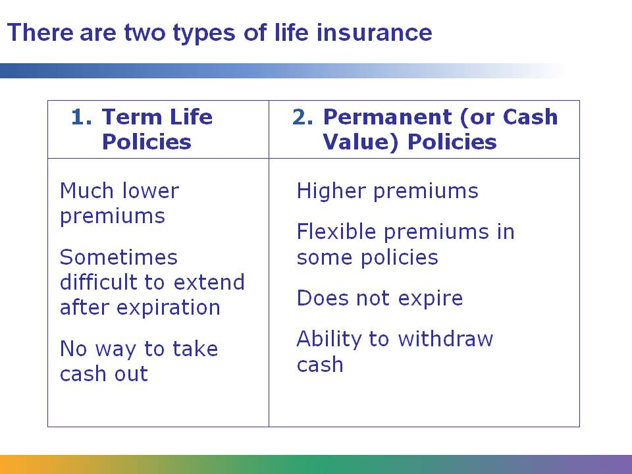
There are many things to take into account when choosing a life insurance policy.
Term life insurance policies have much lower initial premiums but increase as the person insured gets older. Often, they are used by younger families who have not yet invested much money. These policies provide protection to the family if a salary earner dies early. Usually, these are set to expire after the policy holder is likely to be retired and have other significant investments in place.
Permanent policies have higher premiums, but the premium cost usually remains constant or fixed throughout the life of the policy⎯though in some policies they are flexible, and sometimes premiums can even be skipped. These policies are often used by older families who have other investments already in place. These policies provide some tax benefits and long-term protection for the family, as they don’t expire the way a term insurance policy does. They also allow the insured to withdraw money from the policy, with no penalty after a certain age has been reached, or with a penalty if done earlier.
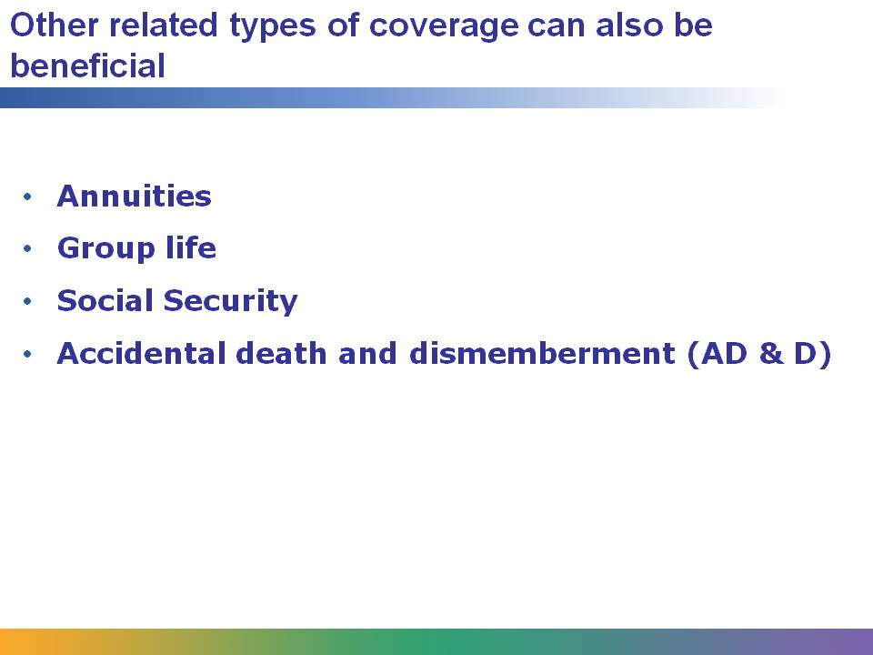
Other types of coverage:
Annuities are financial products that can only be purchased from life insurance companies. They are similar to loans in that the insured pays either a lump sum or a series of payments to the insurance company and the insurance company promises to make a regular payment (often monthly)—either a set amount, or a variable one depending on the performance of an investment tool. Annuities provide a tax benefit and a guaranteed source of income. Retirees can turn a lump sum into a comfortable monthly paycheck that they cannot outlive (as long as the insurer does not go bankrupt). Based on your knowledge of how life insurance works, how do you think insurance companies are able to make a profit on annuities?
Group life is a type of policy that is sometimes provided as a benefit by employers. The employer usually pays the premiums.
Social Security also provides survivor benefits, much like life insurance.
Riders are additions to a life insurance policy. A common rider is accidental death and dismemberment (AD & D), which pays out an increased amount if death is due to an accident. It will also pay out if the insured loses a limb or his sight or hearing.

